FLOOD MANAGEMENT BASED ON IOT

# Project Overview:

This project based on the Internet Of Things that is Flood Management . How we can detect the flood before coming ,this is our project On this project the apparatus required shown belows;

# HARDWARE REQUIMENTS ;

* Hardware Specifications
* Arduino Uno
* Wifi Module
* Temperature Humidity Sensor
* Ultrasonic Sensor
* Water Flow Sensor
* Water Level Sensor
* LCD Display
* Resistors
* Capacitors
* Transistors
* Cables and Connectors
* Diodes
* PCB and Breadboards
* LED
* Transformer/Adapter
* Push Buttons
* Switch
* IC
* IC Sockets

# SOFTWARE REQURIMENTS ;

* Arduino Compiler
* Programming Language: Python
* GIT
* Visual Studio code

# OUTLINE STEPS FOR PROJECT ;

Phase1 : Design Thinks for the flood management

Phase2 : Getting start with ESP32 and work with platfrom

Phase3 : Introducing python programming language

Phase4 : Mobile application Development using MIT app invertor

Phase5 : Build a use case-Smart Home Automation

# BLOCK DIAGRAM

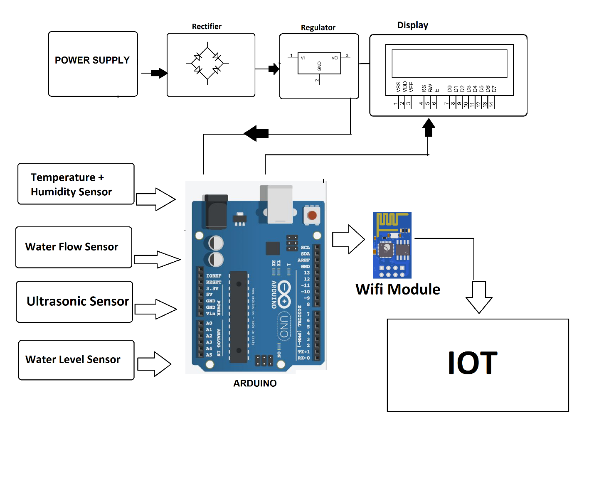

**THIS DESIGN THINKS WAS SUBMITTED BY AN**

**NAME** : P.RAMNIVASS

**EMAIL** : [gg7868500@gmail.com](mailto:gg7868500@gmail.com)

**PROJECT TITTLE** : Flood Management

**ROLL NO** : 713921106042